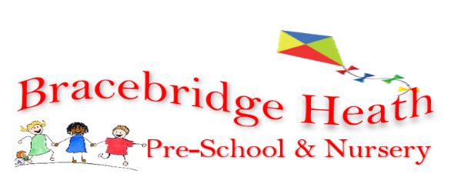

Partnership with Parents Policy

Bracebridge Heath Preschool & Nursery recognises that parents/carers are the first educators of their children; our aim is to work in partnership with parents and carers in providing an environment that supports and involves them in the work of the setting. We will:

• Inform all parents/carers about the setting, how it operates, opening times and policies and procedures through written information found in the Introduction Book, parent notice boards and informal communication and website and our social media platform.

• Provide information on our fee structure, payment policy and the Early Years free place entitlements.

• Assign each child with a key person (EYFS 3.37 2021) with whom the parents will have regular communication. A two year old progress check in working in conjunction with the health visitor if necessary will be carried out for a child’s third birthday EYFS 2.4-2.6 2022)

• Ensure parents/carers have access to their child’s developmental records at any time and access to other records in line with the access to personal information procedure within the Confidentiality policy. Ensure all parents/carers are aware they can discuss their child’s progress and development at any time.

• Ensure all aspects of the child’s achievements and experiences are shared and discussed with the parents. We welcome parents at any time to discuss their child’s development in addition we hold parent events/evenings (appointments may be necessary, please enquire) We do use ‘Tapestry’ for documenting children’s progress and achievements’ We encourage parents/carers to contribute to the shared development record keeping about their child, either being a learning wow moment or a family/individual experience, as these are a useful communication tool for us to further their knowledge and understanding that we can share with others in creative ways to promote our cultural capital or all.

• Provide opportunities for parents/carers to contribute their own skills, knowledge and interest to the activities of the setting. Parents are welcome to come and join in with ‘key group time’ please enquire if you would like to come along.

• Keep parents/carers informed of special activities and themes, through our newsletters, notice boards and different media; which also includes information on the Early Years Foundation Stage initiatives.

• Welcome suggestions and will actively seek parental views via parent questionnaires, therefore ensuring that we are meeting the needs of both children and families.

• Listen to all suggestions and acknowledge that children, parents and staff have the right to be consulted and be heard.

Encourage parents/carers to be part of our committee, or as parent helpers participating in fundraising events, activities, visits or outings.

• Provide all parents with access to our complaints procedure and we will ensure that any complaints are dealt with effectively in accordance with the complaint’s procedure.

This policy has been adopted by: Bracebridge Heath Preschool & Nursery
Signed on behalf of the setting by:

Mrs Joanna Swain .Chairperson

…Mrs Carol Lynn Manager

Review Date: 27/09/2022

